DBMS ASSIGNMENT

TEAM-11

Name:-Nitin Biradar

Roll No:-19BCS080

1). Add, Modify and Delete Column using Alter Command

Use University;

ALTER TABLE dbo.Course_reg_student

ALTER COLUMN Name INT

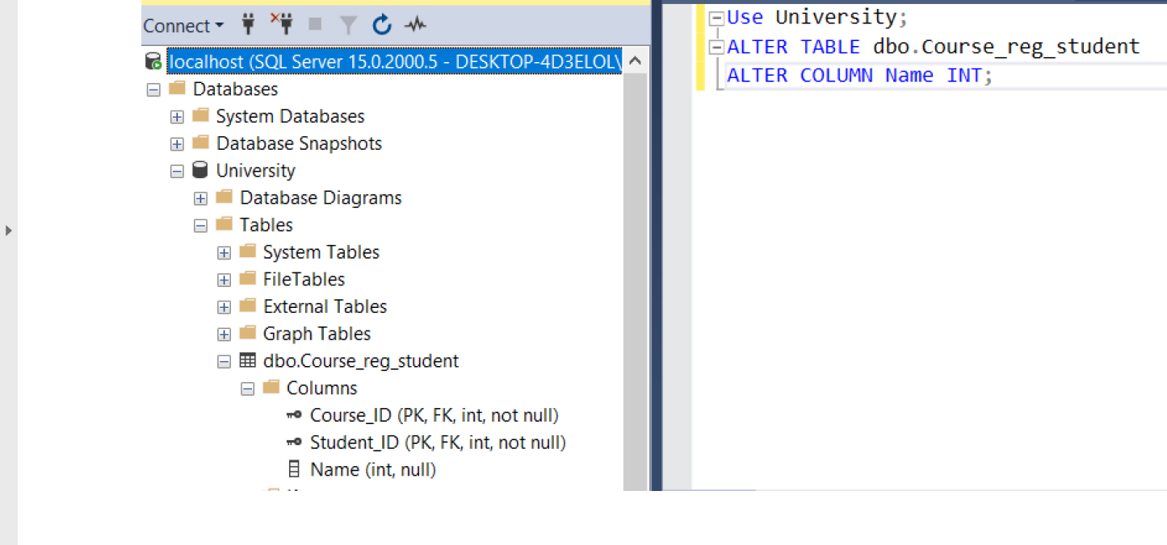

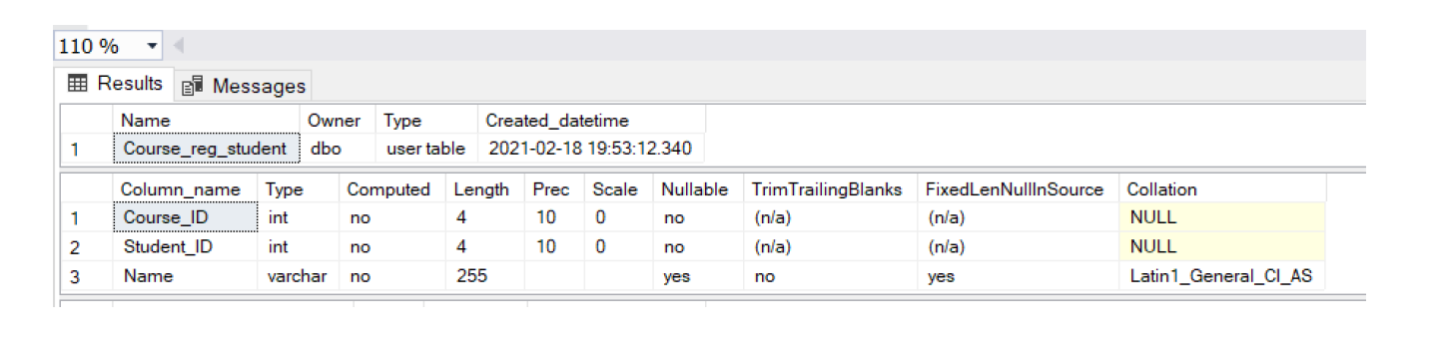

Use University;

ALTER TABLE dbo.Course_reg_student

ADD Name varchar(255);

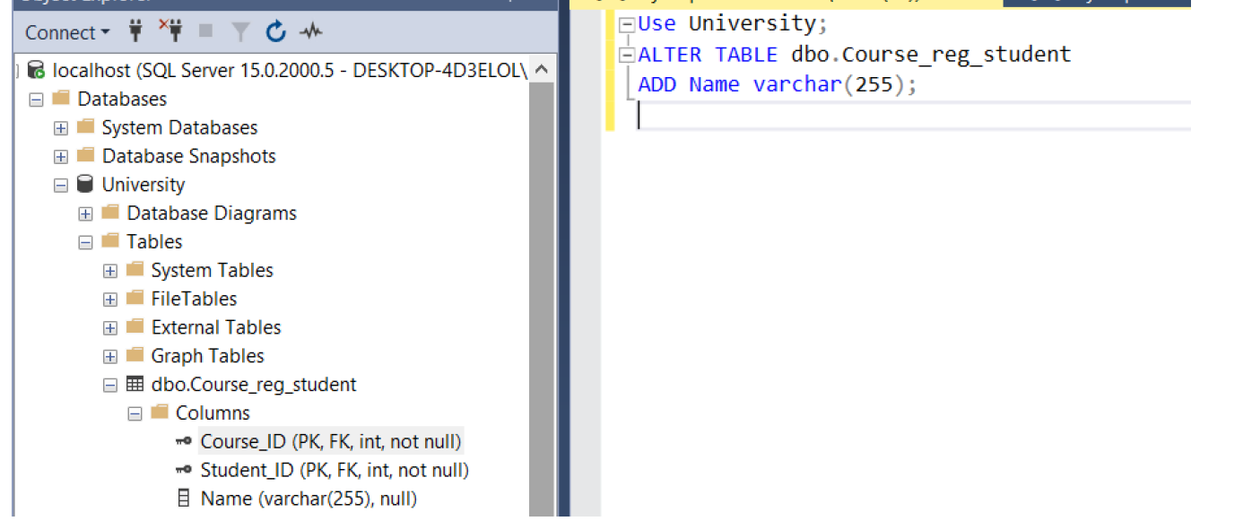

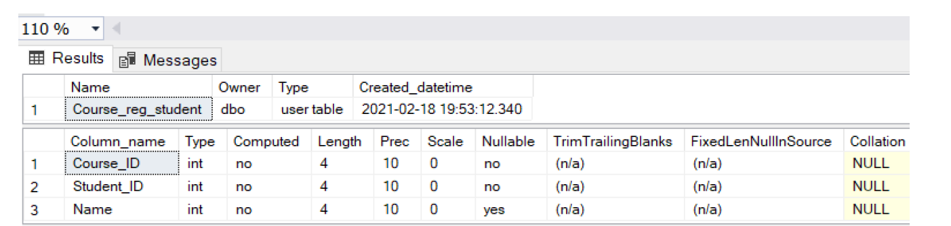

Use University;

ALTER TABLE dbo.Course_reg_student

DROP COLUMN Name

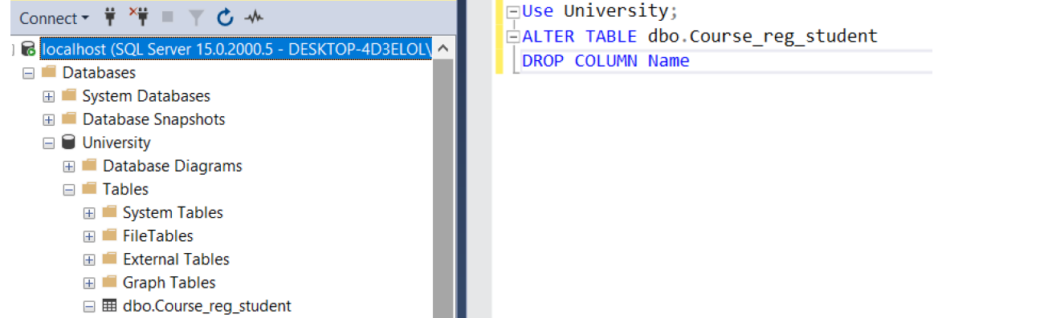

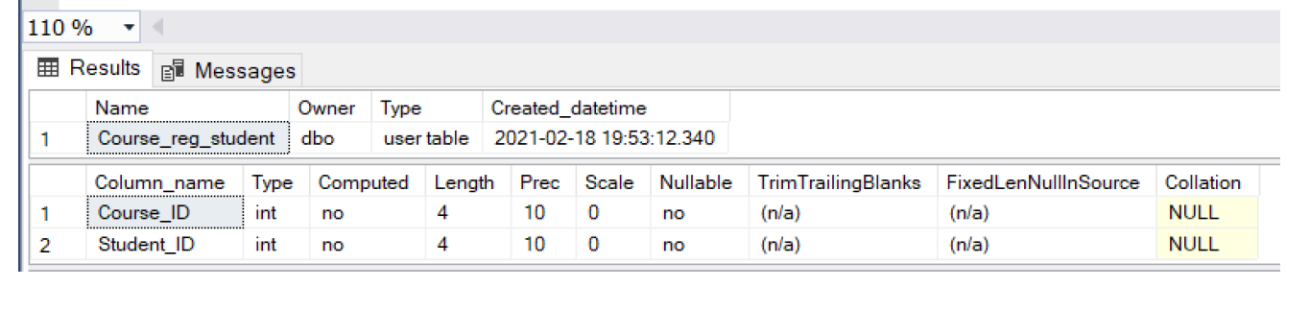

2) Insert 20 Employees Data into all the tables. Use all the 3 methods that I have

Showcased.

INSERT INTO T11_Department

VALUES ('AI', 'A-01');

INSERT INTO T11_Department

VALUES ('CSE', 'C-02');

INSERT INTO T11_Department

VALUES ('ECE', 'E-03');

INSERT INTO T11_Department

VALUES ('BT', 'B-04');

INSERT INTO T11_Department

VALUES ('ME', 'M-05');

INSERT INTO T11_Department

VALUES ('CVE', 'CV-06');

INSERT INTO T11_Department

VALUES ('PHY', 'PH-07');

INSERT INTO T11_Department

VALUES ('MATH', 'MAT-08');

INSERT INTO T11_Department

VALUES ('IT', 'IT-09');

INSERT INTO T11_Department

VALUES ('EEE', 'EE-10');

INSERT INTO T11_Department

VALUES ('AERO', 'AR-11');

INSERT INTO T11_Department

VALUES ('HSE', 'HS-12');

**Output:**

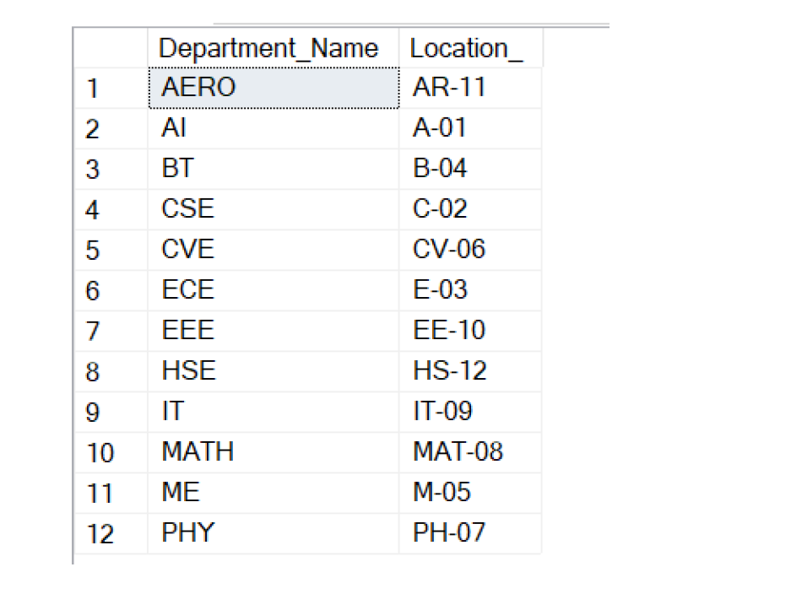

For inserting data into T11_Faculty:

All four methods of inserting shown here-

1) Implicitly inserting data (without providing column names)

2) Specifying column names for insertion explicitly

3) Importing data from another table

4) Using SELECT INTO (creates new table**)**

/* Method 1 of insertion: Implicitly inserting data*/

INSERT INTO T11_Faculty

VALUES (100, 'AI', 1, 'Virat', 'Kohli', 51188);

/* Method 2 of insertion: Specifying column names for insertion*/

INSERT INTO T11_Faculty (Faculty_ID ,Department_Name, HOD, FirstName, LastName, Phone)

VALUES (101, 'CSE', 0, 'Rohit', 'Sharma', 30487);

/* Temporary table for importing data into T11_Faculty*/

CREATE TABLE Faculty_Record

(

Faculty_ID int PRIMARY KEY NOT NULL,

Department_Name varchar(255) FOREIGN KEY REFERENCES

T11_Department(Department_Name) NOT NULL,

HOD bit NOT NULL,

FirstName VARCHAR(255) NOT NULL,

LastName VARCHAR(255),

Phone INT NOT NULL

)

INSERT INTO Faculty_Record

VALUES (102, 'CSE', 1, 'Mahendra Singh', 'Dhoni', 70781);

/* Method 3 of insertion: Importing data from another table*/

INSERT INTO T11_Faculty(Faculty_ID ,Department_Name, HOD, FirstName, LastName, Phone)

SELECT *

FROM Faculty_Record

WHERE Faculty_ID = 102

/* Method 4 of insertion: Using SELECT INTO (creates new table)*/

SELECT

103 AS Faculty_ID,

'AI' AS Department_Name,

0 AS HOD,

'Ajinkya' AS FirstName,

'Rahane' AS LastName,

60688 AS Phone

INTO Test_Table;

INSERT INTO T11_Faculty

VALUES

(103, 'CSE', 0, 'Mithali', 'Raj', 05059),

(104, 'AI', 0, 'Ajinkya', 'Rahane', 60688),

(105, 'ECE', 1, 'Shubhman', 'Gill', 70895),

(106, 'ECE', 0, 'Harleen', 'Deol', 66666),

(107, 'BT', 1, 'Jasprit', 'Bumrah', 99999),

(108, 'BT', 0, 'Ekta', 'Bisht', 54545),

(109, 'AERO', 0, 'Hardik', 'Pandya', 23232),

(110, 'AERO', 1, 'Ravi', 'Ashwin', 11116),

(111, 'ME', 1, 'Ravindra', 'Jadeja', 33890),

(112, 'MATH', 1, 'Che', 'Pujara', 80806),

(113, 'ME', 0, 'Kuldeep', 'Yadav', 93947),

(114, 'CVE', 1, 'Smriti', 'Mandhana', 11112),

(115, 'CVE', 0, 'Md', 'Siraj', 99998),

(116, 'CVE', 0, 'Yuz', 'Chahal', 11117),

(117, 'ECE', 0, 'Rishabh', 'Pant', 11116),

(118, 'HSE', 1, 'Shikhar', 'Dhawan', 11114),

(119, 'AI', 0, 'Bhuvi', 'Kumar', 11113)

;

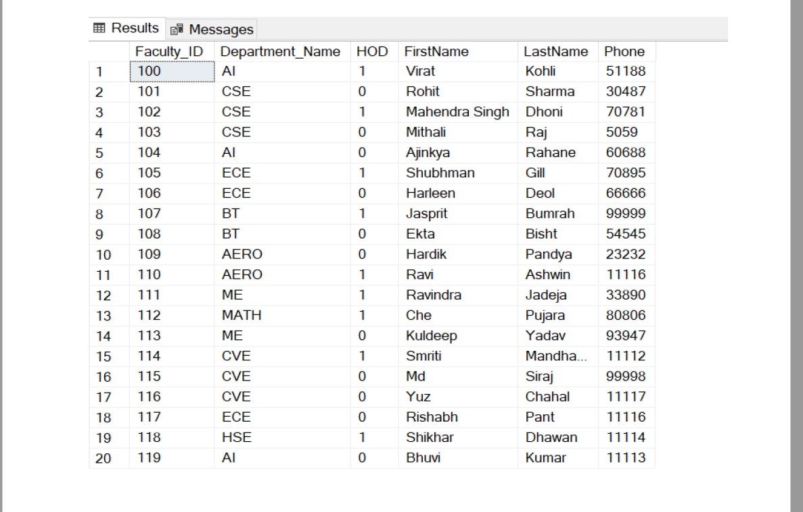

INSERT INTO T11_Student

VALUES

('0001', 'Steve', 'Smith', 490, '1989-06-02', 'M'),

('0002', 'Pat', 'Cummins', 300, '1993-05-08', 'M'),

('0003', 'David', 'Warner', 250, '1986-10-27', 'M'),

('0004', 'Mitchell', 'Starc', 185, '1990-01-30', 'M'),

('0005', 'Josh', 'Philippe', 101, '1997-06-01', 'M'),

('0006', 'Alyssa', 'Healy', 166, '1990-03-24', 'F'),

('0007', 'Meg', 'Lanning', 165, '1992-03-25', 'F'),

('0008', 'Ellyse', 'Perry', 168, '1990-11-03', 'F'),

('0009', 'Rachel', 'Haynes', 170, '1986-12-26', 'F'),

('0010', 'Ashleigh', 'Gardner', 166, '1997-04-15', 'F'),

('0011', 'Joe', 'Root', 200, '1990-12-30', 'M'),

('0012', 'Eoin', 'Morgan', 201, '1986-09-10', 'M'),

('0013', 'Sam', 'Curran', 202, '1998-06-03', 'M'),

('0014', 'Jos', 'Buttler', 203, '1990-09-08', 'M'),

('0015', 'Stuart', 'Broad', 204, '1986-06-24', 'M'),

('0016', 'Heather', 'Knight', 205, '1990-12-26', 'F'),

('0017', 'Nat', 'Sciver', 206, '1992-08-20', 'F'),

('0018', 'Sarah', 'Taylor', 207, '1989-05-20', 'F'),

('0019', 'Amy', 'Jones', 208, '1993-06-13', 'F'),

('0020', 'Danni', 'Wyatt', 209, '1991-04-22', 'F')

;

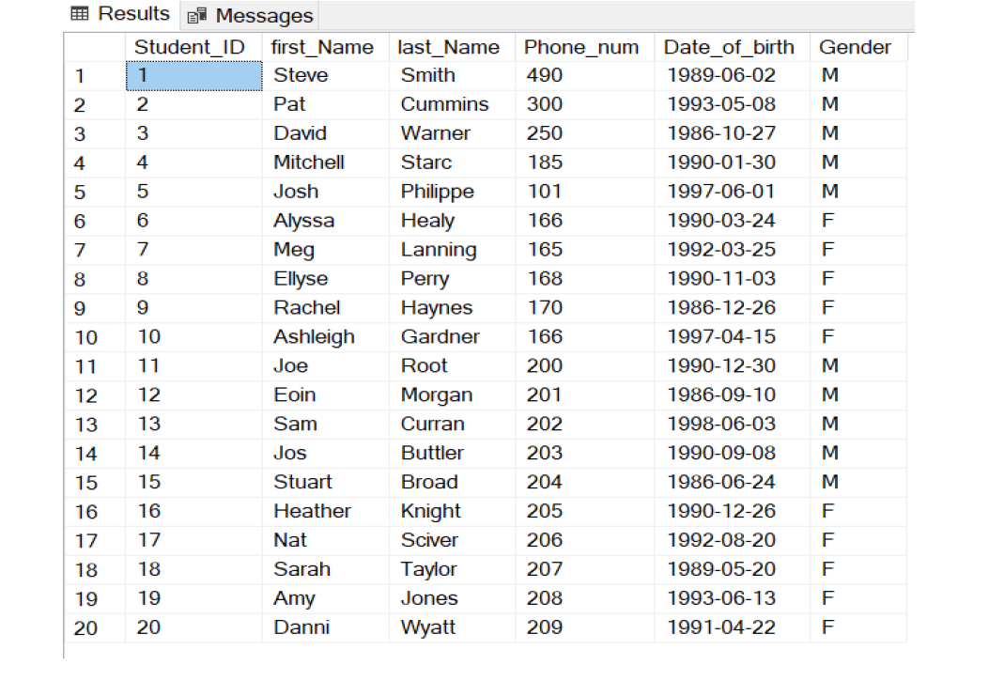

INSERT INTO T11_Student

VALUES

('0001', 'Steve', 'Smith', 490, '1989-06-02', 'M'),

('0002', 'Pat', 'Cummins', 300, '1993-05-08', 'M'),

('0003', 'David', 'Warner', 250, '1986-10-27', 'M'),

('0004', 'Mitchell', 'Starc', 185, '1990-01-30', 'M'),

('0005', 'Josh', 'Philippe', 101, '1997-06-01', 'M'),

('0006', 'Alyssa', 'Healy', 166, '1990-03-24', 'F'),

('0007', 'Meg', 'Lanning', 165, '1992-03-25', 'F'),

('0008', 'Ellyse', 'Perry', 168, '1990-11-03', 'F'),

('0009', 'Rachel', 'Haynes', 170, '1986-12-26', 'F'),

('0010', 'Ashleigh', 'Gardner', 166, '1997-04-15', 'F'),

('0011', 'Joe', 'Root', 200, '1990-12-30', 'M'),

('0012', 'Eoin', 'Morgan', 201, '1986-09-10', 'M'),

('0013', 'Sam', 'Curran', 202, '1998-06-03', 'M'),

('0014', 'Jos', 'Buttler', 203, '1990-09-08', 'M'),

('0015', 'Stuart', 'Broad', 204, '1986-06-24', 'M'),

('0016', 'Heather', 'Knight', 205, '1990-12-26', 'F'),

('0017', 'Nat', 'Sciver', 206, '1992-08-20', 'F'),

('0018', 'Sarah', 'Taylor', 207, '1989-05-20', 'F'),

('0019', 'Amy', 'Jones', 208, '1993-06-13', 'F'),

('0020', 'Danni', 'Wyatt', 209, '1991-04-22', 'F')

;

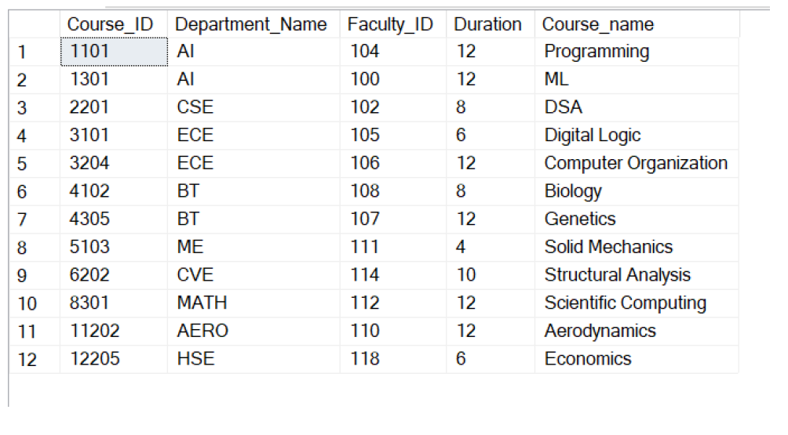

INSERT INTO T11_Course_reg_student

VALUES

(1301, 7),

(8301, 19),

(1301, 12),

(3204, 2),

(4305, 5),

(5103, 16),

(2201, 13),

(6202, 1),

(1101, 10),

(11202, 2)

;

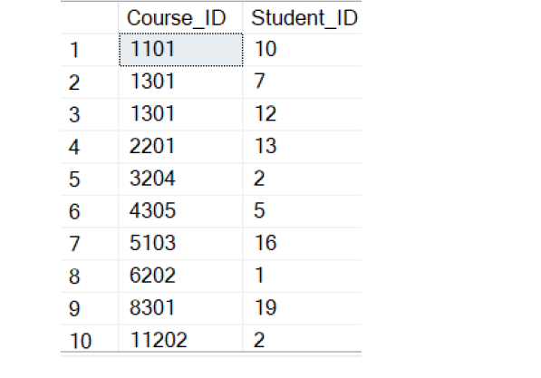

INSERT INTO T11_Research_Projects

VALUES

('P-AI-18', 'NLP', 'Sentiment analysis'),

('P-EC-27', 'VLSI', 'FPGAs'),

('P-M-50', 'PDE', 'Soln of non linear PDE'),

('P-CS-36', 'Algo', 'NP complete'),

('P-BT-88', 'Bio', 'Downstream processing')

;

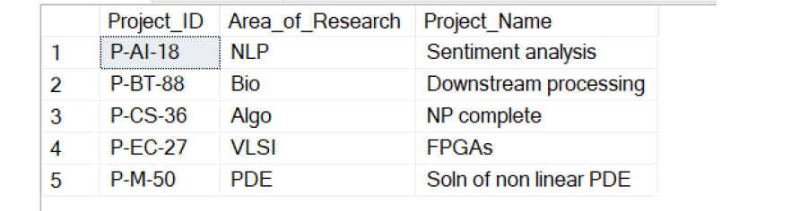

INSERT INTO Instructor_on_Research

VALUES

('P-AI-18', 119, '2019-08-18', NULL),

('P-EC-27', 117, '2020-02-03', NULL),

('P-CS-36', 103, '2020-07-08', NULL)

;

INSERT INTO Instructor_on_Research

VALUES

('P-M-50', 112, '2017-10-01', '2021-02-14'),

('P-BT-88', 108, '2017-11-01', '2021-02-17')

;

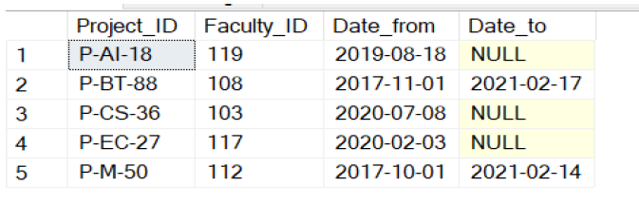

3) Show Violation of Primary Key, Unique Not Null and default key constraints through

Insertion.

Violation of primary key:

USE University;

INSERT INTO T11_Department

VALUES (null, 'A-01');

USE University;

INSERT INTO T11_Department

VALUES ('AI', 'A-108');

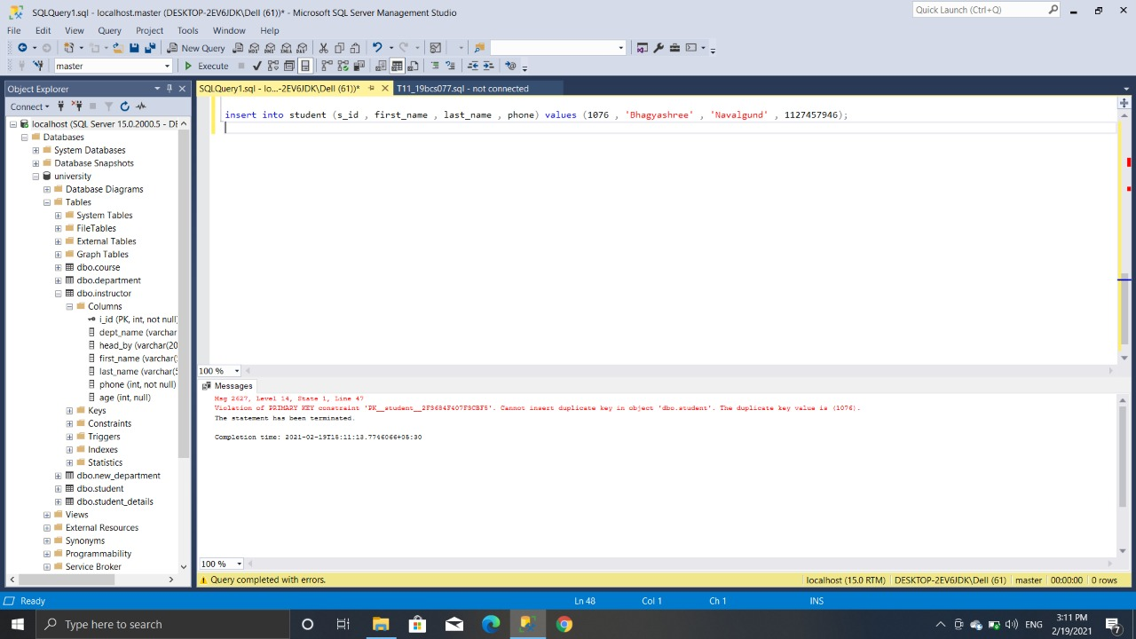

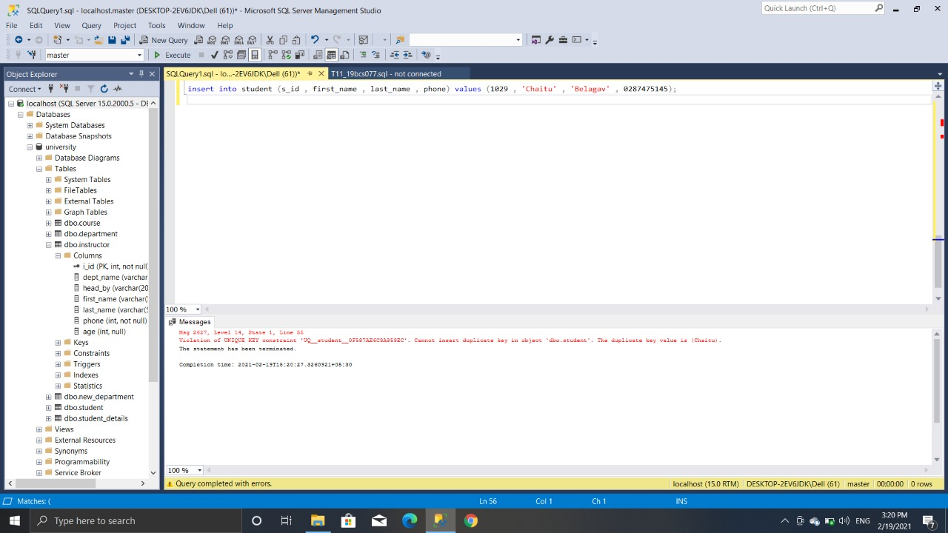

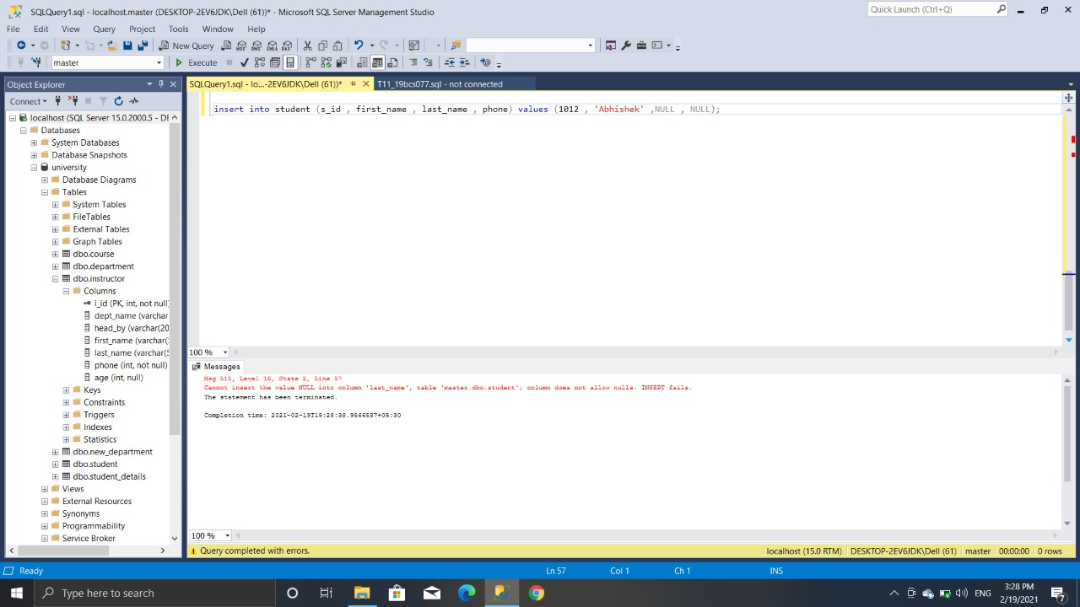

4. Insert tuples into the table and see how foreign key constraint works if you try to insert into dependent table first.

If we insert data into the dependent table first, then it will give a foreign key error, as the referred

table does not have that value. Shown below:

INSERT INTO T11_Faculty

VALUES ('120', 'Chem', 1, 'Harman', 'Kaur', 66666);

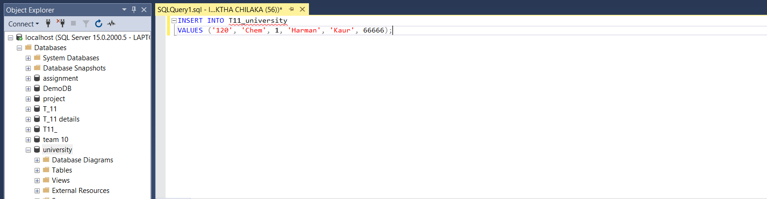

But when we insert into the base table first, and then inserting into the dependent table, it

works.

INSERT INTO T11_Department

VALUES ('Chem', 'Ch-12');

INSERT INTO T4_Faculty

VALUES ('120', 'Chem', 1, 'Harman', 'Kaur', 66666);

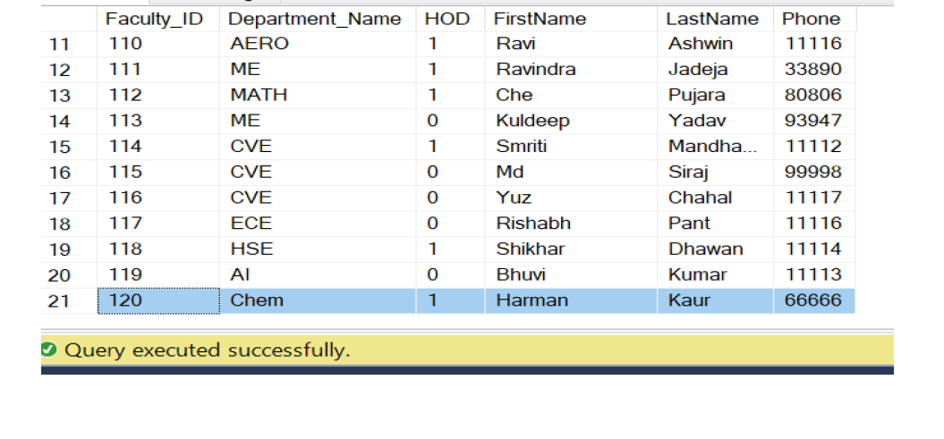

5. Show Violation of Foreign Key Constraint when you try to delete from a base table. If

you get an error explain why deletion gives an error

There is a table name called T11_Course_offered with the following columns:

Course_ID (int), Department_Name (varchar(255)), Faculty_ID (int), Duration (int), Course_name

(varchar(255))

Here, Faculty_ID is a foreign key that references the T11_Department table.

DELETE FROM T11_Department WHERE Faculty_id = 1

We get the error “update or delete on table "T11_Department" violates foreign key constraint.

As Faculty_ID is a foreign key in table T11_Department; the reason you are unable to delete

employee ID 1 is because Faculty_ID 1 exists on T11_Department. The system is trying to maintain

integrity of the database by preventing you from deleting an employee affiliated with

T11_Department.

6. Try to update a non-existing entity data and check for error.

Here we are trying to update Student_Id to ‘9999’ in T11_Student whose first_name is ‘HiFi’ but

there does no exist first_name = ‘HiFi’ in T11_Student .

But it accepts the query and showing no error.

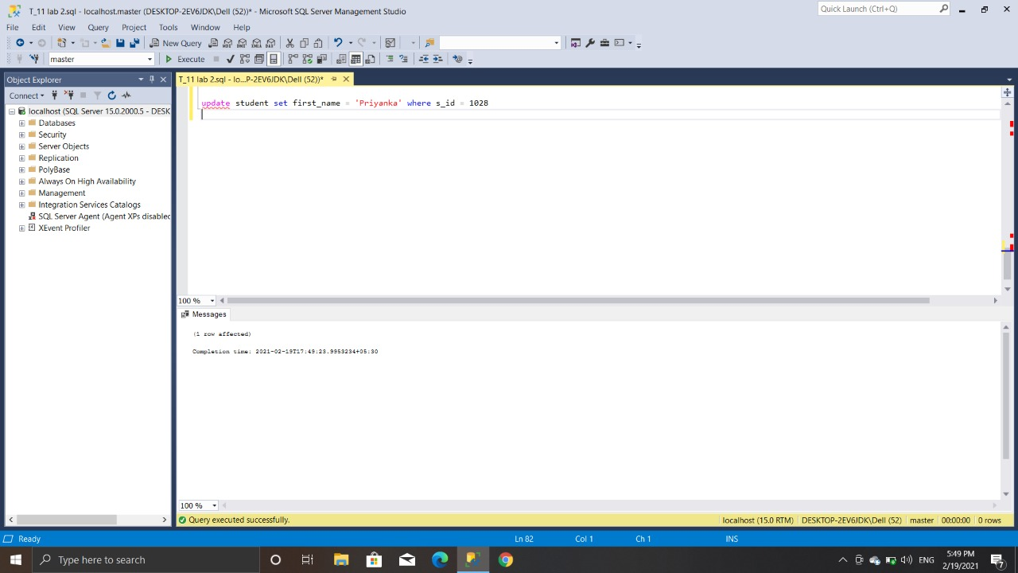

7. Add a column which has default value.

/* Temporary table to show insertion of default data */

CREATE TABLE Faculty_Record

(

Faculty_ID int PRIMARY KEY NOT NULL,

Department_Name varchar(255) FOREIGN KEY REFERENCES

T11_Department(Department_Name) NOT NULL,

HOD bit NOT NULL,

FirstName VARCHAR(255) NOT NULL,

LastName VARCHAR(255),

Phone INT NOT NULL

)

INSERT INTO Faculty_Record

VALUES

(103, 'CSE', 0, 'Mithali', 'Raj', 05059),

(104, 'AI', 0, 'Ajinkya', 'Rahane', 60688),

(105, 'ECE', 1, 'Shubhman', 'Gill', 70895),

(106, 'ECE', 0, 'Harleen', 'Deol', 66666),

(107, 'BT', 1, 'Jasprit', 'Bumrah', 99999),

(108, 'BT', 0, 'Ekta', 'Bisht', 54545)

;

ALTER TABLE Faculty_Record

ADD PhD_from varchar(255) NULL

CONSTRAINT PhD_from DEFAULT 'IIT'

WITH VALUES;

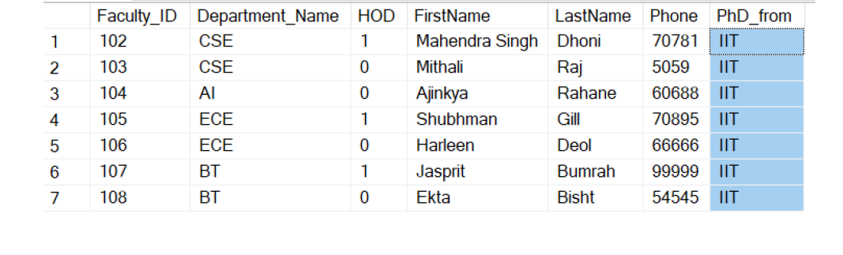

8. 5 Simple Select queries to retrieve data from your database.

SELECT first_Name FROM T11_Student WHERE Student_ID IN ('003');

SELECT * FROM T11_Student WHERE Student_ID IN ('003');

SELECT COUNT(*) FROM T11_Faculty;

SELECT Concat(first_Name, ' ', last_Name) FROM T11_Student;

SELECT Student_ID, first_Name FROM T11_Student;

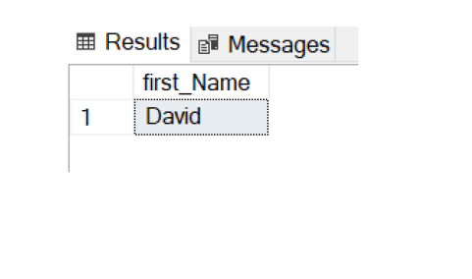

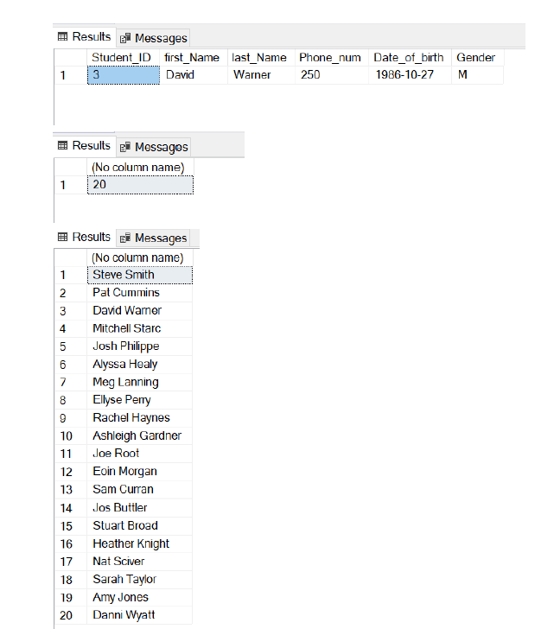

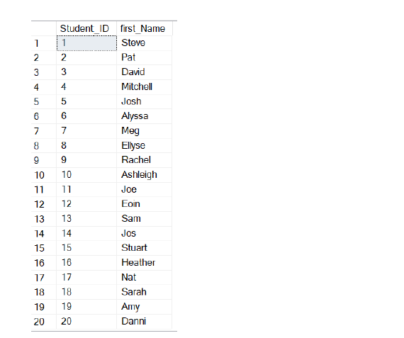

9. Show how Foreign key constraint affects updating a dependent table when value is not existing and in the base table where the value is referred and you want to update it.

We have tables T11_Department and T11_Faculty. In T11_Faculty, the attribute named

Department_Name is the foreign key which references the T11_Department table. Thus,

T11_Faculty is the dependent table and T11_Department is the base table.

To show how foreign key constraints affect updating a dependent table when value does not

exist:

/* We are trying to update the Department_Name (FK) to 'Mining' which does not exist. */

UPDATE T11_Faculty

SET Department_Name ='Mining'

WHERE Faculty_ID = 105;